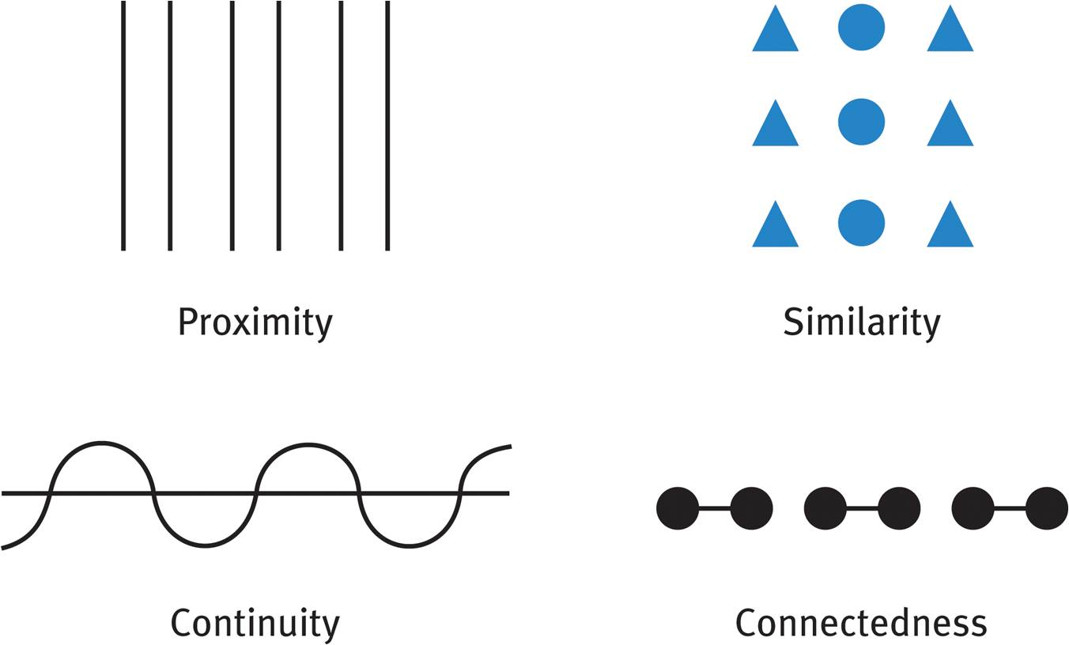
1 2 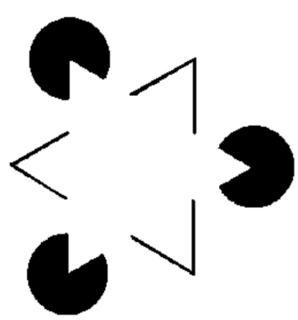
3 4

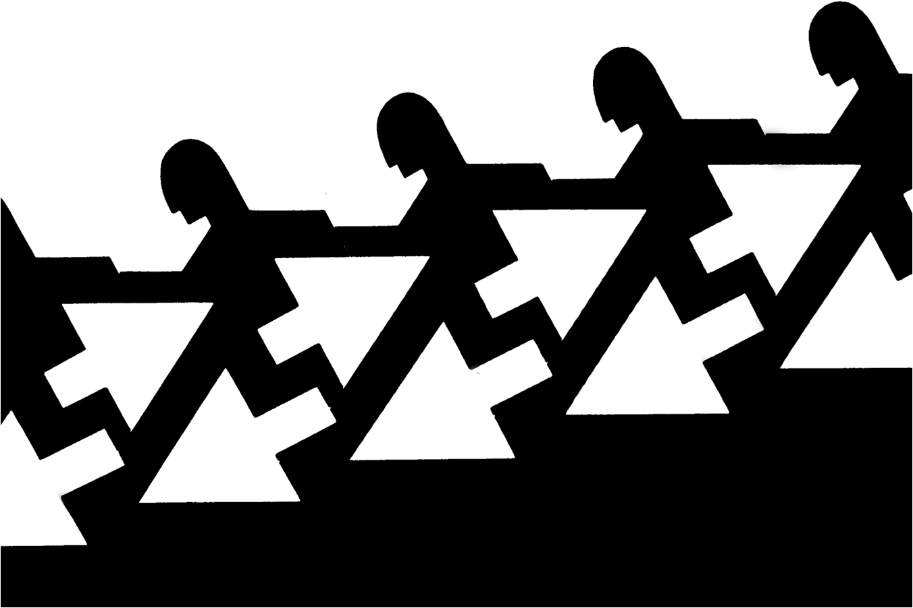
5

Name (4 points each) and describe (8 points each) each of the Gestalt Principles illustrated above (60 points total):
1 | 2
3 | 4
5
Choose one of the illustrations (by number and name) and explain how top down and/or bottom up processing might apply in interpreting that principle (20 points).
Compare and contrast the processes of sensation and perception (what are the similarities and differences) and explain how they work together (20 points).
References

